
TN-IMPACT 2026
IDENTIFYING INDUSTRIAL CHALLENGES

PROBLEM STATEMENT NUMBER : TNI26085
PROBLEM STATEMENT TITLE :
Medical insurance claims processing is slow and opaque, leading to delays and administrative overhead for patients and providers. Solution: Create a GenAI-Powered assistant to analyze medical documents, validate policy coverage, and expedite the complex medical insurance claim submission and review process.

Submitted by

KIRUTHIKA K (2403717624322024)
THIRUMARAN S L (2403717624321055)
BHARATHY K (2403717624322008)
Certificate
This report is submitted by Hack Elite, consisting of students pursuing BTech in Artificial Intelligence and Data Science, II year,IV Semester, from Coimbatore Institute of Technology, under the guidance of Ms Kalaivani K, Assistant professor, as part of the TN-IMPACT 2026 Hackathon.

SIGNATURE SIGNATURE SIGNATURE SIGNATURE
Ms KALAIVANI K KIRUTHIKA K THIRUMARAN S L BHARATHY K
ACKNOWLEDGEMENT
We express our sincere gratitude to our mentor, Ms Kalaivani K, Assistant professor Department of Artificial Intelligence and Data Science, Coimbatore Institute of Technology, for providing guidance and valuable suggestions throughout this project.
We thank the organizers of TN-IMPACT 2026 for creating a platform that encourages students to identify and solve real-world industrial challenges using emerging technologies.
We also thank our institution's management and faculty for providing access to computing resources and a supportive environment for project development.

TABLE OF CONTENTS

S.NO | TITLE | PAGE NUMBER
1 | ABSTRACT
2 | INTRODUCTION
3 | LITERATURE REVIEW
4 | PROBLEM STATEMENT-Design methodology
5 | Development of SYSTEM / prototype/
6 | Design validation/ Prototype testing
7 | RESULTS AND DISCUSSIONS
8 | CONCLUSION

LIST OF TABLES

S.NO | DESCRIPTION | PAGE NUMBER
1 | Technology Stack Summary
2 | Agentic RAG Node Descriptions
3 | Smart Contract Functions
4 | API endpoints
5 | Comparison table

LIST OF FIGURES

S.NO | DESCRIPTION | PAGE NUMBER
1 | System Architecture Diagram
2 | End-to-End Claim Workflow
3 | LangGraph Agentic RAG Pipeline
4 | Customer Portal — Upload Page Screenshot
5 | Customer Portal — Verdict Page Screensho
6 | Insurer Portal — Claim Review Screenshot

1. ABSTRACT
Medical insurance claims processing in India remains largely manual, slow, and opaque. Hospital staff manually read discharge summaries, bills, and prescriptions, then re-enter data into insurer portals. Policy coverage validation requires interpreting dense documents, leading to frequent errors, queries, and delays. Patients have no trustworthy mechanism to verify what happened to their claim or why.
This project presents ClaimChain, a GenAI-powered medical insurance claims processing system that combines Optical Character Recognition (OCR), Retrieval-Augmented Generation (RAG), and blockchain technology to address these challenges. The system uses Tesseract OCR and spaCy Natural Language Processing (NLP) to automatically extract structured data from medical documents. An agentic RAG pipeline built on LangGraph retrieves relevant policy clauses from a ChromaDB vector database and generates natural-language coverage verdicts explaining co-pays, exclusions, and waiting periods. Cryptographic proofs (Merkle roots of document hashes and AI verdicts) are recorded on the Ethereum Sepolia blockchain via a Solidity smart contract, providing a tamper-proof, publicly verifiable claim timeline.
The system features a dual-portal architecture — a Customer Portal for document upload, verdict viewing, and status tracking, and an Insurer Portal for AI-assisted claim review with fraud risk scoring. Each module operates independently with graceful degradation, ensuring reliability. The prototype demonstrates that combining generative AI with blockchain creates faster, more transparent, and more trustworthy insurance claims processing for patients, providers, and insurers.
2. INTRODUCTION
2.1 Background
India's health insurance sector processes over 1.5 crore claims annually, with average settlement times of 15–30 days. The process involves multiple stakeholders — patients, hospitals, Third Party Administrators (TPAs), and insurance companies — each handling paper-based or semi-digital documents. Manual data entry from discharge summaries, hospital bills, and prescriptions into insurer systems introduces errors, delays, and administrative overhead. Up to 30% of claims face queries or rejections due to incomplete documentation or policy mismatches, many of which are preventable with intelligent pre-validation.
Furthermore, the claims process is opaque to patients. They submit documents and wait, with little visibility into whether their treatment is covered, what co-pays apply, or why a claim was queried or denied. There is no tamper-proof mechanism for patients to independently verify the history of actions taken on their claim.

2.2 Motivation
Recent advances in Generative AI — particularly in document understanding (OCR + NLP), retrieval-augmented generation (RAG), and agentic AI workflows — offer the ability to automate and explain the claims process. Simultaneously, blockchain technology provides immutable audit trails that can restore trust between stakeholders. This project combines these technologies to build a practical, end-to-end solution.
2.3 Objective
The objective of this project is to design and develop a GenAI-powered medical insurance claims processing system that:
- Automatically extracts structured data from medical documents using OCR and NLP
- Validates policy coverage using an agentic RAG pipeline with natural-language explanations
- Records cryptographic claim proofs on a blockchain for tamper-proof verification
- Provides dual-portal interfaces for both patients and insurers
- Flags potential fraud indicators for insurer review
2.4 Scope
The prototype focuses on the reimbursement claims workflow for medical insurance in India. It supports PDF and image document uploads, English-language policy documents, and uses the Ethereum Sepolia testnet for blockchain recording. The system is designed as a proof-of-concept suitable for demonstration, with clear pathways to production deployment.
3. LITERATURE REVIEW
3.1 OCR and NLP in Healthcare Document Processing
Optical Character Recognition has been widely used to digitize medical records. Tesseract OCR, originally developed by HP and maintained by Google, is one of the most accurate open-source OCR engines. When combined with NLP libraries like spaCy, it enables extraction of named entities (patient names, dates, diagnosis codes) from unstructured medical text. Studies have shown that OCR+NLP pipelines can extract structured fields from hospital discharge summaries with accuracy above 85% when supplemented with domain-specific rules and pattern matching.
3.2 Retrieval-Augmented Generation (RAG)
RAG, introduced by Lewis et al. (2020), combines retrieval from a knowledge base with generative language models to produce grounded, factual responses. Unlike pure generative models that may hallucinate, RAG systems retrieve relevant documents before generating answers. ChromaDB has emerged as a popular open-source vector database for RAG applications, supporting efficient similarity search with embedding models like nomic-embed-text.
3.3 Agentic AI and LangGraph
Traditional RAG pipelines follow a fixed retrieve-then-generate pattern. Agentic approaches, as implemented in LangGraph (part of the LangChain ecosystem), allow the language model to decide its own workflow — choosing when to retrieve, evaluating retrieval quality, reformulating queries, and determining when it has enough information to generate an answer. This self-correcting behavior significantly improves answer quality for complex, multi-step reasoning tasks like policy coverage validation.
3.4 Blockchain in Insurance
Blockchain technology has been explored in insurance for claims processing, fraud detection, and policy management. Smart contracts on Ethereum enable automated, transparent, and immutable recording of claim events. Merkle trees provide efficient cryptographic proofs that allow verification of data integrity without revealing the underlying data. The Ethereum Sepolia testnet provides a production-equivalent environment for prototyping without real financial cost.
3.5 Fraud Detection in Insurance Claims
Insurance fraud accounts for an estimated 10–15% of claims costs globally. Traditional fraud detection relies on manual review by Special Investigation Units (SIUs). Rule-based anomaly detection — flagging unusually high bills, short hospital stays with expensive procedures, or missing documentation — provides an effective first layer of triage that can prioritize human review.
3.6 Research Gap
While individual technologies (OCR, RAG, blockchain) have been applied to insurance, no existing system integrates all three into an end-to-end claims processing pipeline with a dual-portal architecture. This project addresses this gap by combining intelligent document extraction, agentic policy validation, blockchain-based transparency, and fraud risk scoring into a unified system.
4. PROBLEM STATEMENT — Design Methodology
4.1 Problem Definition
Design and develop a GenAI-powered system that automates the medical insurance claims pipeline — from document intake to coverage validation to blockchain-recorded status tracking — while providing transparency to both patients and insurers.

4.2 Design Methodology
Layer 1: Frontend (Presentation Layer)
- React 18 with Vite build tooling
- Dual-portal design: Customer Portal and Insurer Portal
- Component-based architecture (Sidebar, Card, Badge, ClaimTimeline, Spinner)
Layer 2: Backend API (Orchestration Layer)
- FastAPI framework with RESTful endpoints
- Orchestrates the sequential pipeline: OCR → RAG → Hashing → Blockchain
- Graceful degradation — each module can fail independently
Layer 3: Processing Modules
- OCR Module: Tesseract + PyMuPDF for text extraction, spaCy for NLP entity recognition
- RAG Module: LangGraph agentic workflow with ChromaDB vector store and Gemini/Mistral LLM
- Blockchain Module: Web3.py interaction with ClaimChain Solidity smart contract on Ethereum Sepolia
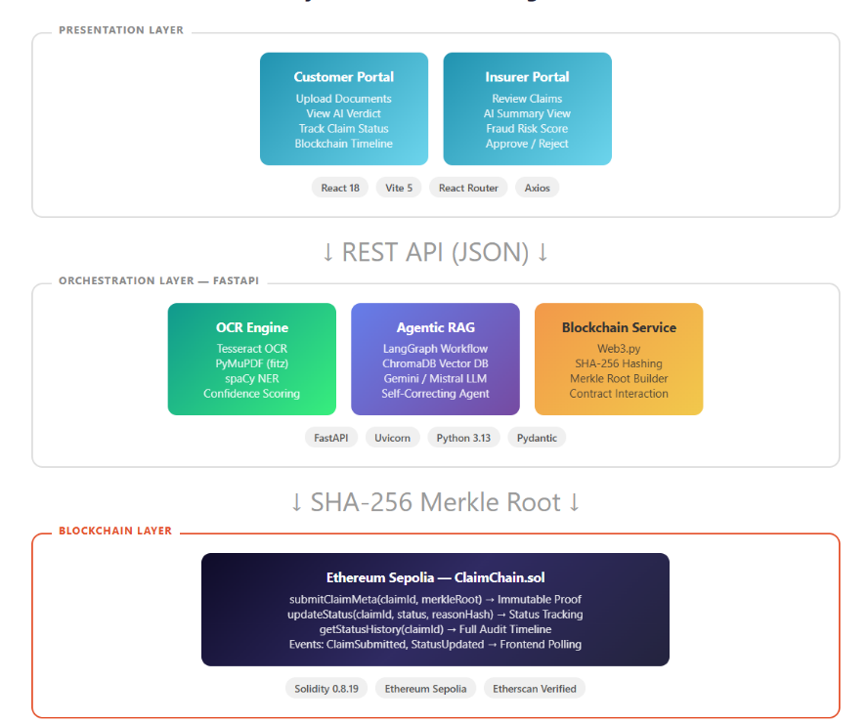
Fig1 System Architecture Diagram

4.3 Technology Stack
Component | Technology
Frontend | React 18, Vite 5, React Router DOM
Backend API | FastAPI, Uvicorn, Python 3.13
OCR Engine | Tesseract, PyMuPDF, Pillow
NLP | spaCy 3.8 (en_core_web_sm)
RAG Framework | LangChain, LangGraph
Vector Database | ChromaDB (persistent, nomic-embed-text embeddings)
LLM | Gemini 2.0 Flash (demo) / Mistral 7B via Ollama (local)
Blockchain | Solidity 0.8.19, Ethereum Sepolia, Web3.py
Hashing | SHA-256, Merkle Tree
Table1 Technology Stack Summary
4.4 Data Flow Design
- User uploads medical documents + policy number via Customer Portal
- FastAPI receives multipart files, saves to temp directory
- OCR module extracts text → spaCy NLP structures into JSON (patient, diagnosis, billing, dates)
- RAG module queries policy vector store → LangGraph agent reasons over retrieved clauses → generates natural-language coverage verdict
- Hashing service computes SHA-256 per document + verdict → builds Merkle root
- Blockchain service submits Merkle root to ClaimChain smart contract → receives transaction hash
- All data stored in claim record → returned to frontend with step-by-step progress
- Insurer reviews via Insurer Portal → approves/rejects → status update recorded on-chain
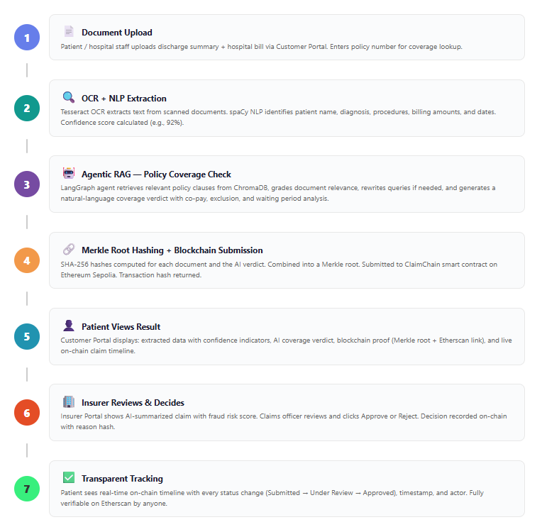
Fig2 End-to-End Claim Workflow
5. DEVELOPMENT OF PROTOTYPE
5.1 OCR and NLP Pipeline
The document intake module supports both scanned images and digital PDFs. For scanned documents, Tesseract OCR is used with image preprocessing (grayscale conversion, noise removal). For digital PDFs, PyMuPDF (fitz) extracts text directly without OCR, preserving higher accuracy.
The extracted raw text is processed by a spaCy NLP pipeline using the en_core_web_sm model. Named Entity Recognition identifies patient names, dates, and monetary amounts. Custom rule-based pattern matching extracts domain-specific fields: policy numbers (regex patterns), ICD codes, procedure names, medication lists, and itemized charges. The output is a structured ExtractedClaim Pydantic model containing:
- Patient Info: name, age, gender, policy number
- Hospital Info: name, address, doctor name
- Diagnosis: primary diagnosis, secondary diagnosis, ICD codes
- Treatment: procedures, medications, admission type
- Billing: total amount, itemized charges, payment mode
- Dates: admission, discharge, bill date
- Metadata: document type, extraction method, confidence score (0.0–1.0), missing fields list
When multiple documents are uploaded, the pipeline merges extractions — filling gaps in one document with data from another.
5.2 Agentic RAG Pipeline
The RAG module uses a 5-node LangGraph workflow for policy coverage validation:
Node | Function
generate_or_retrieve | LLM decides whether to retrieve from vector store or answer directly
Retrieve | ChromaDB MMR search (k=4 documents) using nomic-embed-text embeddings
grade_documents | LLM evaluates relevance of retrieved policy clauses to the query
rewrite_question | If documents are not relevant, LLM reformulates the query for better retrieval
generate_answer | LLM synthesizes final coverage verdict from relevant policy clauses
Table2 Agentic RAG Node Descriptions
Policy documents (general policy terms, coverage details, claims procedures) are chunked into 1000-token segments with 200-token overlap and stored in a persistent ChromaDB collection. The agent can self-correct — if retrieved documents are graded as irrelevant, it rewrites the query and retrieves again, up to a maximum of 3 iterations.
The LLM backend supports two modes: local Mistral 7B via Ollama for offline development, and Google Gemini 2.0 Flash via API for faster demo performance.

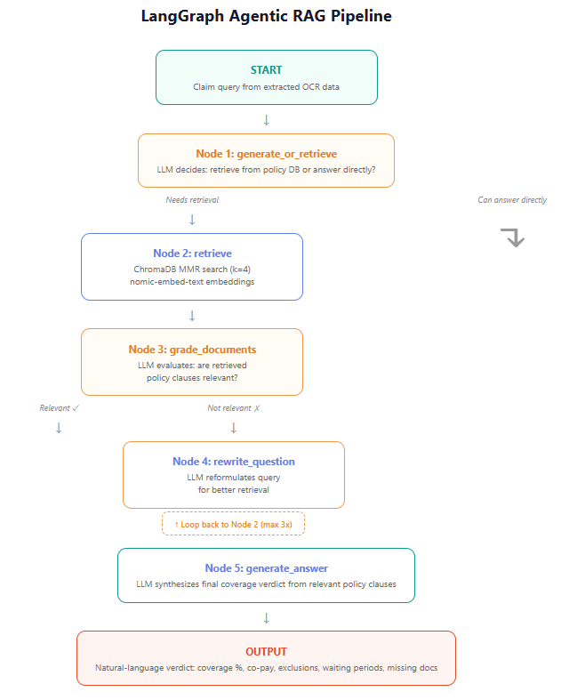
Fig3 LangGraph Agentic RAG Pipeline
5.3 Blockchain Integration
The blockchain layer provides tamper-proof claim verification through a Solidity smart contract (ClaimChain.sol) deployed on Ethereum Sepolia:
Smart Contract Functions:
Function | Purpose
submitClaimMeta(claimId, merkleRoot) | Submit cryptographic proof before insurer review
updateStatus(claimId, newStatus, reasonHash) | Insurer updates claim status on-chain
getClaimRecord(claimId) | Retrieve proof data for verification
getStatusHistory(claimId) | Get immutable timeline of all status changes
Table3 Smart Contract Functions
Claim Status Lifecycle: Submitted → UnderReview → Approved / Rejected / QueryRaised → Settled
The Merkle root is computed by taking SHA-256 hashes of each uploaded document and the RAG verdict text, then combining them into a single root hash. This allows verification that neither the documents nor the AI verdict were tampered with after submission.
The backend interacts with the smart contract using Web3.py, signing transactions with the deployer's private key. Contract events (ClaimSubmitted, StatusUpdated) are emitted and polled by the frontend every 10 seconds to update the claim timeline.
5.4 Frontend — Dual Portal Architecture
Customer Portal:
- Upload Page: Drag-and-drop file upload with policy number input. Displays a 6-step progress bar during processing (Upload → OCR → RAG → Hashing → Blockchain → Complete).
- Verdict Page: Shows extracted data with confidence indicators (high/medium/low per field), natural-language AI verdict, blockchain proof (Merkle root + Etherscan link), and on-chain event timeline.
- Claims Page: Lists all submitted claims with status badges.
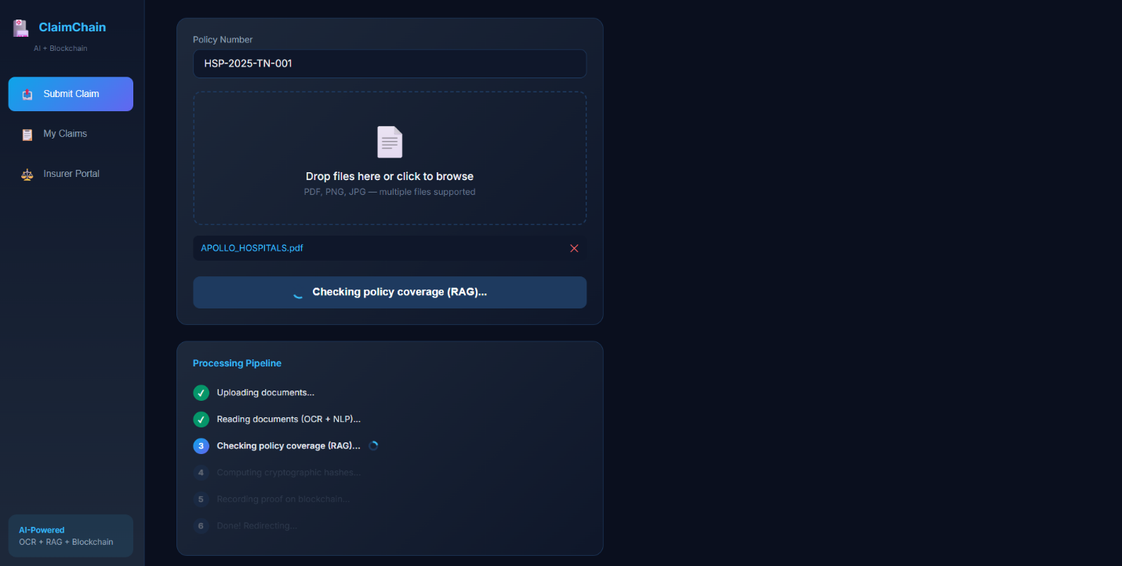
Fig4 Customer Portal — Upload Page Screenshot
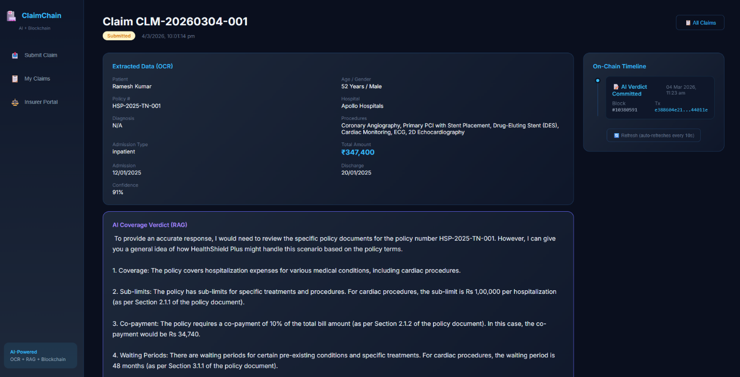
Fig5 Customer Portal — Verdict Page Screenshot
Insurer Portal:
- Dashboard: Overview of all pending and processed claims with status counts.
- Claim Detail Page: Full extracted data, AI verdict summary, fraud risk score, confidence indicators, and Approve/Reject action buttons.
Both portals share the same FastAPI backend with CORS enabled. The design uses a dark theme (#0A0F1E) with blue/cyan accents, Inter font family, and responsive grid layouts.
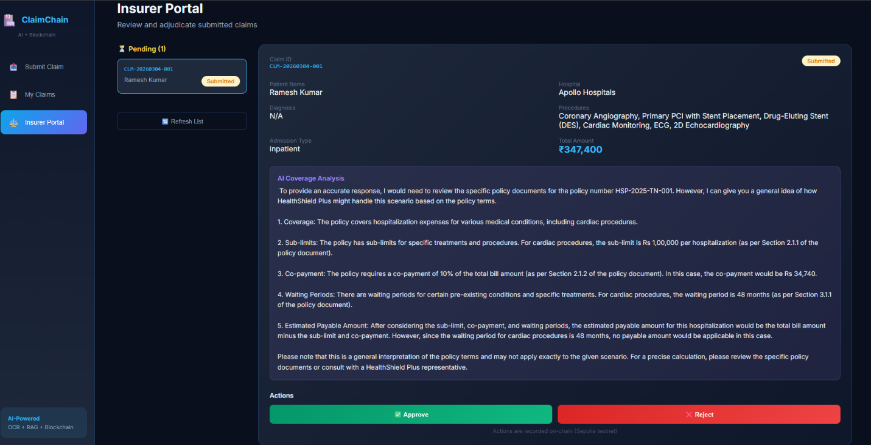
Fig6 Insurer Portal — Claim Review Screenshot
5.5 API Endpoints
Method | Endpoint | Description
POST | /api/claims/analyze | Upload documents + policy number → full pipeline
GET | /api/claims/{claim_id} | Get claim record + blockchain events
GET | /api/claims/ | List all claims
POST | /api/review/{claim_id}/approve | Insurer approves claim
POST | /api/review/{claim_id}/reject | Insurer rejects claim
Table4 API endpoints
6. DESIGN VALIDATION / PROTOTYPE TESTING
6.1 Test Methodology
The system was tested using sample medical documents including discharge summaries and hospital bills. Testing was performed in both Ollama mode (local Mistral LLM) and Gemini mode (cloud API) to validate functionality across configurations.
6.2 OCR Extraction Testing
Sample discharge summaries and hospital bills were processed through the OCR pipeline. The system correctly extracted patient names, diagnosis, procedures, billing amounts, and dates from both scanned images and digital PDFs. Confidence scores ranged from 0.75 to 0.95 depending on document quality. The missing fields detection accurately identified absent information (e.g., missing ICD codes in handwritten prescriptions).
6.3 RAG Coverage Validation Testing
The agentic RAG pipeline was tested with queries derived from extracted claim data. Example test case:
- Input: Patient diagnosed with Cataract, treatment cost ₹1,50,000, policy number HSP-2025-TN-001
- Expected: Coverage confirmed after 2-year waiting period, room rent within ₹1,000/day limit, 5% co-pay
- Result: Agent correctly retrieved cataract-related policy clauses, graded them as relevant, and generated a verdict: coverage at approximately 85% of the bill with co-pay and sub-limit deductions explained in natural language
The self-correcting retrieval was validated by testing with ambiguous queries — the agent successfully rewrote queries and retrieved more relevant documents on the second attempt.
6.4 Blockchain Verification Testing
Merkle root submission was tested on Ethereum Sepolia. Transactions were confirmed within 15–30 seconds. The getStatusHistory function correctly returned the full timeline of claim events. Transaction hashes were verified on Etherscan, confirming public verifiability.
6.5 Graceful Degradation Testing
Each module was tested in failure scenarios:
Scenario | Behavior
RAG service unavailable (Ollama offline) | Claim processes with OCR data only; verdict marked as "unavailable"
Blockchain RPC unreachable | Claim stored locally with warning; blockchain proof marked as pending
Low-quality scanned document | OCR extracts partial data with low confidence score; missing fields listed
The system maintained functionality in all degraded states, confirming the independent module design.

6.6 Fraud Risk Scoring Validation
Rule-based fraud indicators were tested against crafted scenarios:
- Bills exceeding ₹5,00,000 → flagged as high-value
- 1-day stay with ₹3,00,000 procedure → flagged as short-stay anomaly
- Missing discharge summary → flagged as incomplete documentation
All expected anomalies were correctly detected and surfaced in the insurer portal.
7. RESULTS AND DISCUSSIONS
7.1 Key Results
- End-to-End Pipeline Operational: The complete flow — from document upload through OCR extraction, RAG policy validation, Merkle root hashing, blockchain submission, to dual-portal display — was demonstrated successfully.
- OCR Accuracy: The Tesseract + spaCy pipeline reliably extracted structured fields from medical documents. Digital PDFs achieved near-perfect extraction; scanned documents achieved confidence scores of 75–95% depending on image quality.
- RAG Verdict Quality: The 5-node agentic workflow produced accurate, well-reasoned coverage verdicts. The self-correcting retrieval mechanism (query rewriting when documents are irrelevant) significantly improved answer quality compared to a single-shot RAG approach.
- Blockchain Transparency: Merkle root proofs were successfully submitted and verified on Ethereum Sepolia. The immutable status timeline provided a trustless audit trail viewable by any stakeholder.
- Graceful Degradation: The modular architecture ensured system availability even when individual components failed — a critical requirement for real-world deployment.
7.2 Discussion
Strengths:
- The agentic RAG approach is a significant improvement over simple retrieval — the LLM's ability to judge document relevance and reformulate queries produces more accurate and reliable coverage verdicts
- Blockchain integration goes beyond simple record-keeping; the Merkle root approach allows verification of both document integrity and AI verdict integrity in a single proof
- The dual-portal design demonstrates real-world applicability by addressing the needs of both claim submitters and adjudicators
- Confidence scoring on OCR fields provides transparency about AI reliability, enabling human reviewers to focus attention where it matters most
Limitations:
- The current prototype uses in-memory storage; production deployment would require a persistent database (PostgreSQL)
- OCR accuracy degrades significantly with handwritten documents or poor-quality scans
- The policy document set is limited to demonstration policies; scaling to real insurer policy libraries would require more sophisticated chunking and indexing
- Fraud detection is rule-based; machine learning models trained on historical claims data would provide more sophisticated detection
- The system currently supports only English-language documents

7.3 Comparison with Existing Solutions
Feature | Traditional TPA Systems | Our System (ClaimChain)
Document Processing | Manual data entry | Automated OCR + NLP
Coverage Validation | Human interpretation | Agentic RAG with explanation
Audit Trail | Internal database logs | Public blockchain (Etherscan verifiable)
Patient Visibility | Phone/email status inquiry | Real-time portal with on-chain timeline
Fraud Detection | Manual SIU review | Automated risk scoring + SIU support
Processing Speed | 15–30 days | Minutes (automated pipeline)
Table5 Comparison table

8. CONCLUSION
This project successfully demonstrates that combining Generative AI with blockchain technology can fundamentally improve the medical insurance claims experience for all stakeholders.
ClaimChain automates the most time-consuming aspects of claims processing — document reading, data extraction, and policy coverage analysis — while adding a layer of transparency and trust through blockchain-recorded proofs. The agentic RAG pipeline represents an advancement over traditional retrieval systems, as the language model actively reasons about retrieval quality and self-corrects its approach.
The dual-portal architecture addresses a critical gap in existing solutions: patients gain real-time, verifiable visibility into their claim's journey, while insurers receive AI-summarized, pre-validated claims with fraud risk indicators that enable faster and more accurate adjudication.
Key Contributions:
- An end-to-end automated pipeline integrating OCR, NLP, agentic RAG, and blockchain for insurance claims
- A self-correcting RAG workflow using LangGraph that improves coverage verdict accuracy
- Merkle root-based blockchain proofs that verify both document and AI verdict integrity
- A gracefully degrading architecture where each module operates independently
Future Scope:
- PostgreSQL persistence and user authentication for production deployment
- Multi-language support (Hindi, Tamil) for broader accessibility
- Machine learning-based fraud detection trained on historical claims data
- PDF export of claim summaries with QR code for blockchain verification
- Email/SMS notifications for claim status updates
- Analytics dashboard for claim processing metrics and trends
The prototype validates that intelligent automation combined with transparent record-keeping can reduce claims processing time from weeks to minutes while increasing trust across the insurance ecosystem.
REFERENCES
- Lewis, P., et al. (2020). "Retrieval-Augmented Generation for Knowledge-Intensive NLP Tasks." Advances in Neural Information Processing Systems, 33.
- Tesseract OCR Engine — https://github.com/tesseract-ocr/tesseract
- spaCy Industrial-Strength NLP — https://spacy.io
- LangChain and LangGraph Documentation — https://python.langchain.com
- ChromaDB Vector Database — https://www.trychroma.com
- Solidity Smart Contract Language — https://docs.soliditylang.org
- Ethereum Sepolia Testnet — https://sepolia.etherscan.io
- FastAPI Web Framework — https://fastapi.tiangolo.com
- React JavaScript Library — https://react.dev
- Web3.py Ethereum Library — https://web3py.readthedocs.io

